2015年中国·腾冲国际半程马拉松赛报名表
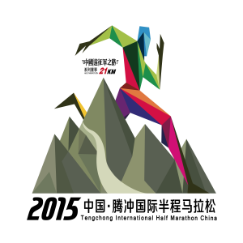
2015Tengchong International Half Marathon China
Individual Entry Form

半程马拉松  Half Marathon |  | 健康欢乐跑  6KM

姓名  Name |  |  | 男  Male |  |  | 女  Female |  |  | 出生年月日  Date of Birth
身份证  I.D.Number |  |  |  |  |  |  |  |  | 服装尺码  L/M/S
单位地址、邮编  Company's Address and Postal Code |  |  |  |  |  |  |  |  |  |  | 血型  Blood Group
家庭住址  Home Address |  |  |  |  |  |  | 联系电话  Tel.: |  |  |  | 邮编  Postal Code
最好成绩  Best Result |  |  |  |  |  |  | 比赛名称  Name of Event |  |  |  | 日期  Date
本人声明：
1、我自愿参加2015年中国·腾冲国际半程马拉松赛，并明白参加此项比赛对健康状况有特殊要求以及潜在的不安全因素。
2、我自觉严格遵守本届比赛大会的所有规定，为参加比赛已做好充分训练和准备，本人已经医疗机构体检，身体健康，有能力参加此活动。愿意承担自身的意外风险责任，并无权向大会对本人在活动中发生或引致的自身意外、死亡或任何形式的损失索赔或追究责任。
3、本人在此比赛中的姓名、照片、声像愿意无偿提供给大会宣传所用。
1. I apply to participate in the 2015Tengchong International Half Marathon China Race of my own free will, and I am aware of the special requirement for the health condition and potential risks involved in these events.
2. I agree to abide by and follow the rules established by the organizing side, and have made full preparation and training for the race. I have gotten a medical checkup from the medical institution and been proved to be health and capable of participating in these events. I voluntarily assume all the risks occurring during the Event and agree that the organizing side is not responsible for any compensation and liability of the injuries, death or other forms of loss.
3. In relation to the races the organizing side and the designated media are entitled to use my portraits, name, voice and other personal information free of charge for the organizing and popularization of the Event.

参赛者签名 日期
Signature of Participant : ________________ Date: ____________________

备用联系电话Alternative Phone Inc:

此表只适用于不能在线支付的报名者

